EXPT NO: 7 | GENERATE SYNTHETIC IMAGES USING A GENERATIVE ADVERSARIAL NETWORK (GAN)
DATE: 05.10.2026

PRE-LAB QUESTIONS (PROVIDE BRIEF ANSWERS TO THE FOLLOWING QUESTIONS)

- What is a Generative Adversarial Network (GAN)?
A GAN is a type of deep learning model used to generate new data, such as images, that look similar to real data. It consists of two neural networks: a Generator and a Discriminator.

- What are the roles of the Generator and Discriminator in a GAN?
Generator: Creates fake/synthetic images from random noise.
Discriminator: Checks whether an image is real or generated (fake).
Both networks learn together to improve the quality of generated images.

- Why are GANs used for synthetic image generation?
GANs can generate realistic images that are similar to real images in the training dataset. They are useful for creating new images, data augmentation, and generating images when real data is limited.

- What is the difference between real images and synthetic images?
Real images: Captured or collected from real-world sources.
Synthetic images: Artificially generated by a computer or AI model.
Synthetic images may look realistic but are not directly captured from the real world.

- Explain the concept of adversarial training in GANs.
Adversarial training means the Generator and Discriminator compete with each other. The Generator tries to create images that fool the Discriminator, while the Discriminator tries to correctly identify real and fake images. Through this competition, the Generator gradually learns to create more realistic images.

AIM
To implement a Generative Adversarial Network (GAN) for generating synthetic images by training a Generator and Discriminator on an image dataset and evaluating the quality of the generated images.

SOFTWARE REQUIREMENTS
- Python
- TensorFlow / Keras
- Google Colab
- GitHub
- NumPy
- Matplotlib
- Pandas

OBJECTIVES
Students will be able to:
- Understand the architecture and working of Generative Adversarial Networks.
- Understand the roles of the Generator and Discriminator.
- Prepare and preprocess an image dataset for GAN training.
- Build a Generator network for synthetic image generation.
- Build a Discriminator network for distinguishing real and generated images.
- Train a GAN using adversarial learning.
- Generate synthetic images using the trained Generator.
- Visualize and analyze the quality of generated images.

PROCEDURE
PART A: DATASET PREPARATION AND IMAGE PREPROCESSING
Perform the following tasks:
- Load an image dataset such as the MNIST handwritten digit dataset.
- Explore the dataset and examine sample images.
- Check the number of images and image dimensions.
- Display sample images from the dataset.
- Normalize the pixel values to the range [-1, 1].
- Reshape the images into the required input format.
- Prepare the dataset for batch-wise training.
- Create a data pipeline using appropriate TensorFlow/Keras utilities.

CODE:
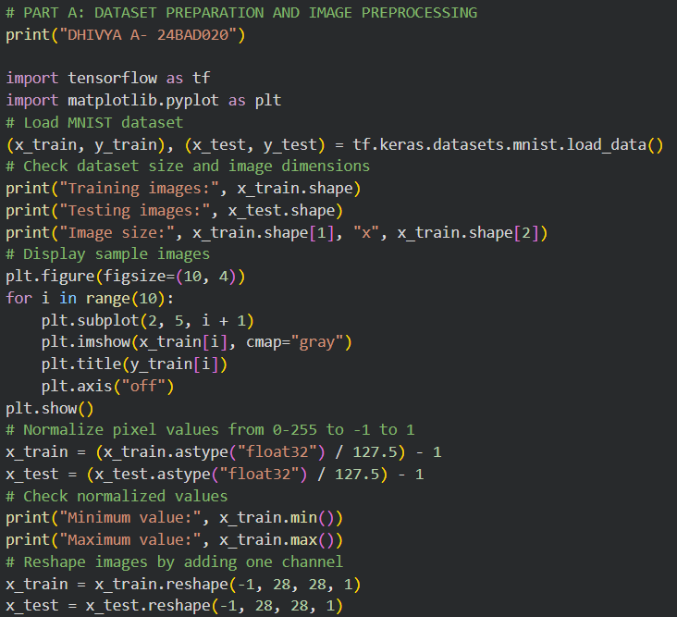
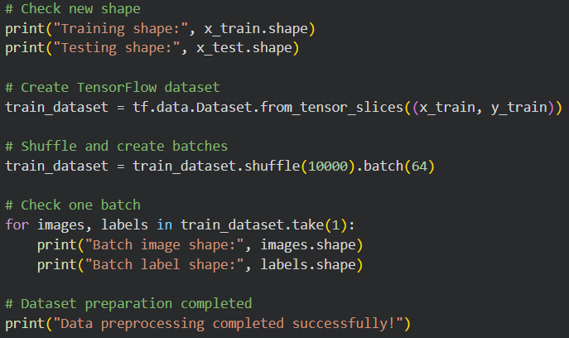

OUTPUT:
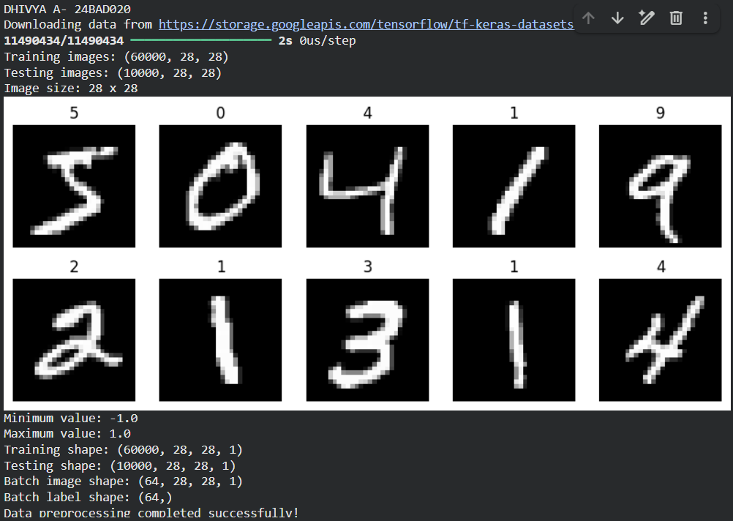

PART B: IMPLEMENTING THE GENERATOR
Perform the following tasks:
- Define a random noise vector as the input to the Generator.
- Create the Generator using appropriate neural network layers.
- Use Dense and convolutional/transposed convolutional layers to generate images.
- Apply appropriate activation functions.
- Generate an image from a random noise vector.
- Display the generated image before GAN training.
- Display the Generator model architecture and summary.

CODE:
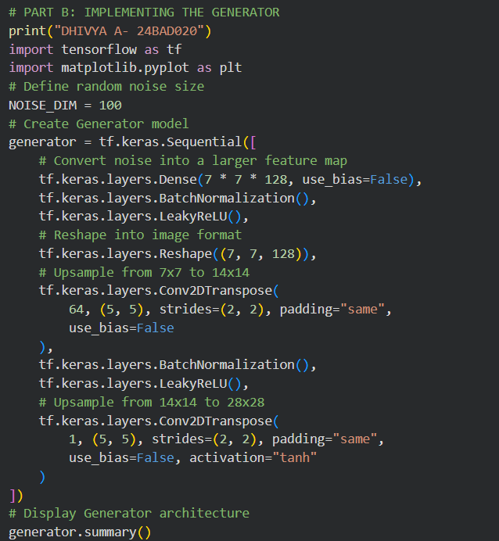
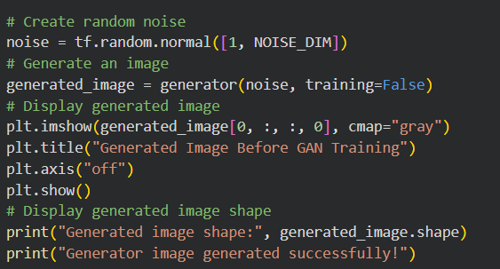

OUTPUT:
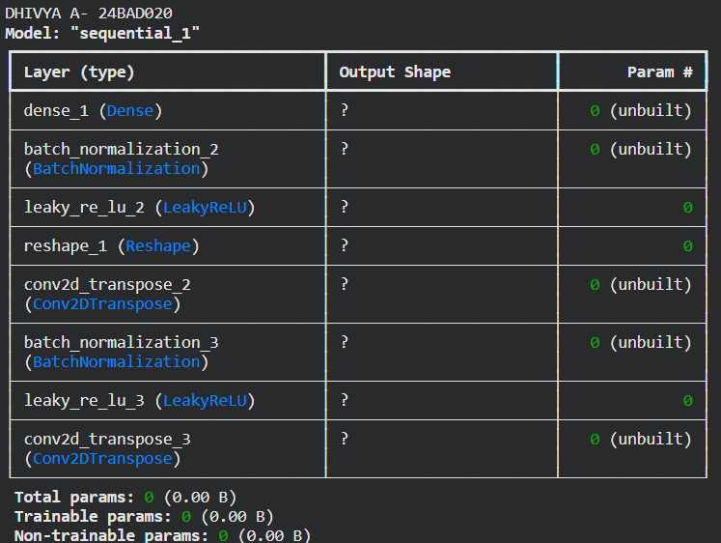

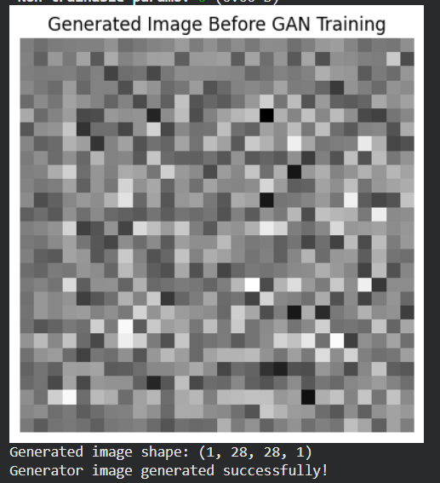

PART C: IMPLEMENTING THE DISCRIMINATOR AND GAN MODEL
Perform the following tasks:
- Create a Discriminator network to classify images as real or generated.
- Add convolutional layers to extract image features.
- Add appropriate activation functions.
- Add a final output layer for binary classification.
- Compile the Discriminator using:
  - Appropriate optimizer
  - Binary cross-entropy loss
- Combine the Generator and Discriminator to form the GAN.
- Display the Generator and Discriminator model summaries.
CODE:
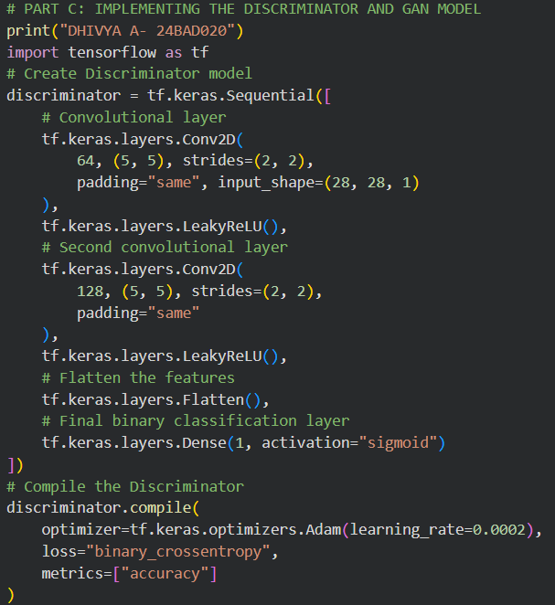
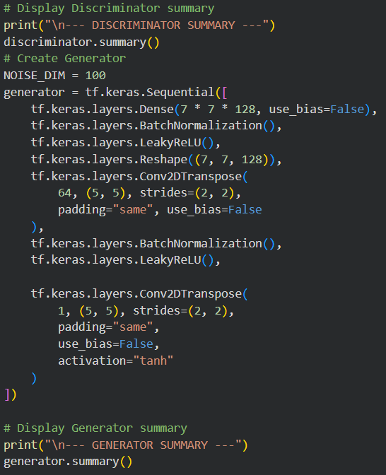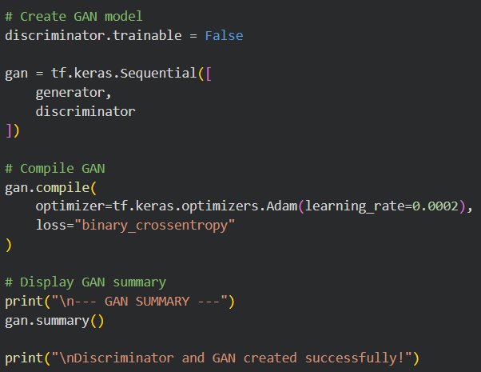

OUTPUT:
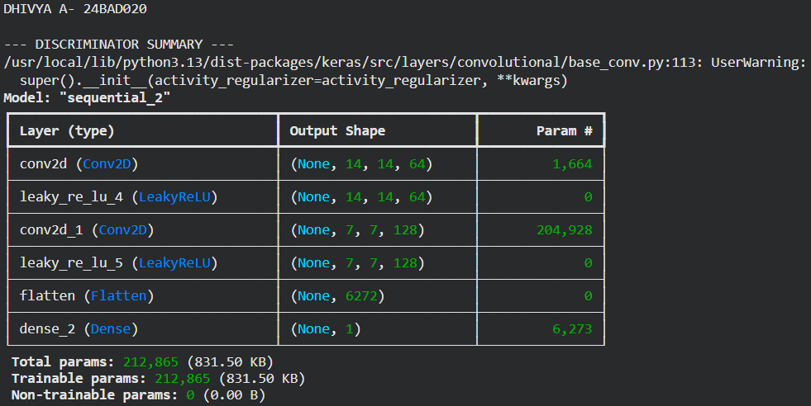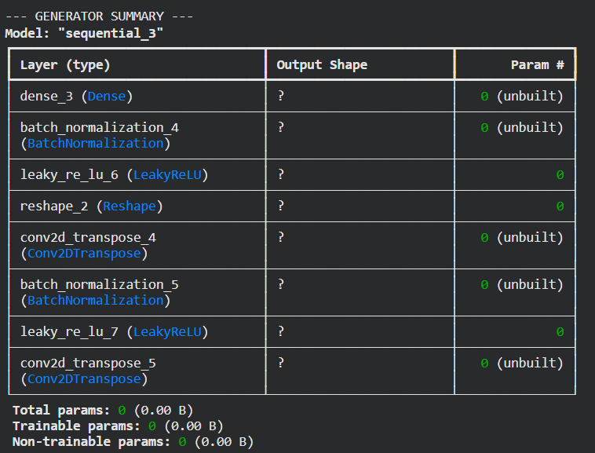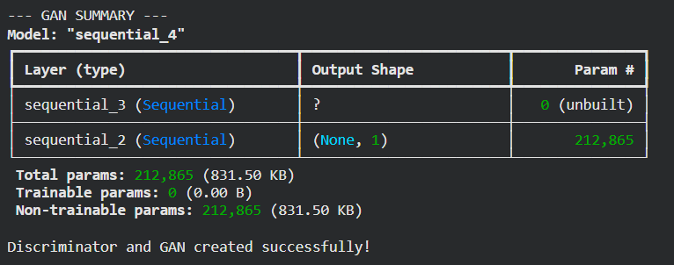

PART D: GAN TRAINING AND SYNTHETIC IMAGE GENERATION
Perform the following tasks:
- Initialize the Generator with random noise.
- Train the Discriminator using:
  - Real images from the dataset.
  - Synthetic images generated by the Generator.
- Train the Generator through the combined GAN model.
- Record:
  - Generator loss
  - Discriminator loss
- Repeat the training process for the specified number of epochs.
- Generate synthetic images at regular training intervals.
- Visualize generated images at different stages of training.
- Compare the generated images with real images.
- Analyze the quality and diversity of the generated images.
- Save the final generated images.
CODE:
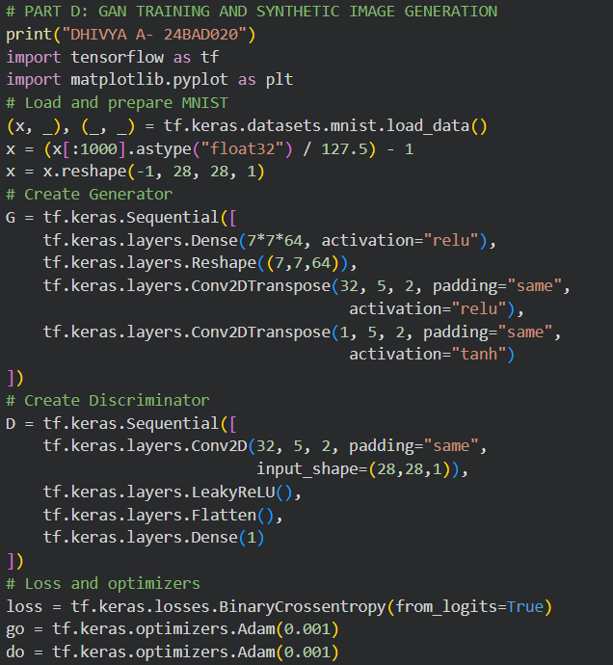
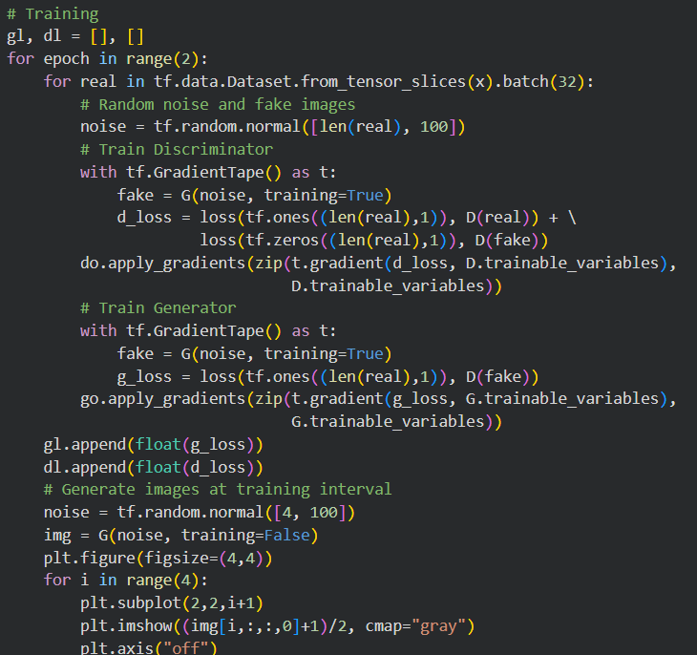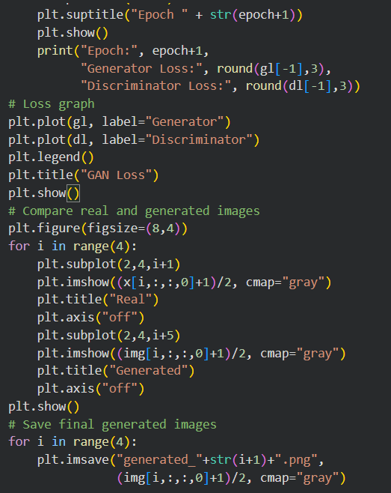

OUTPUT:
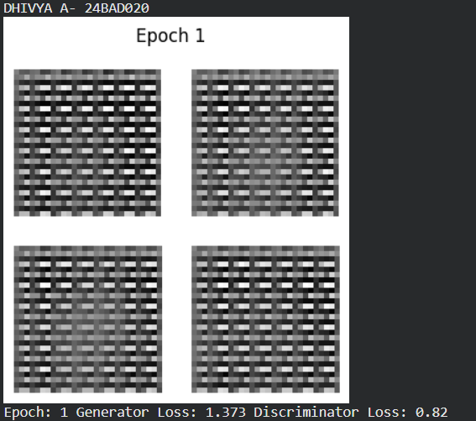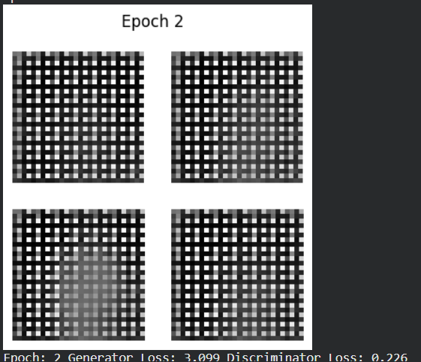
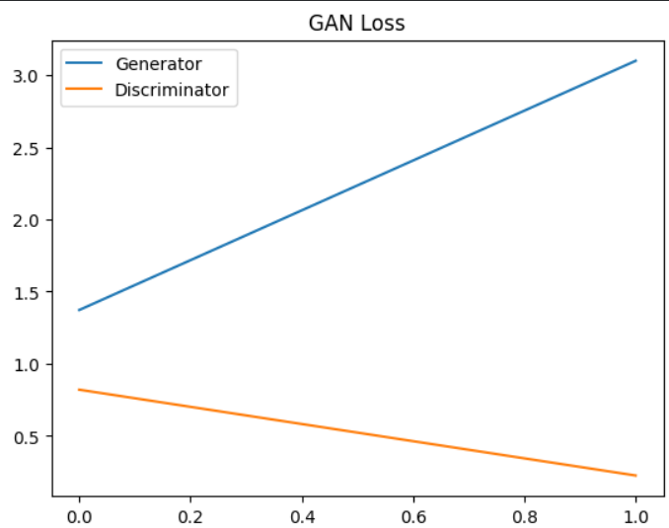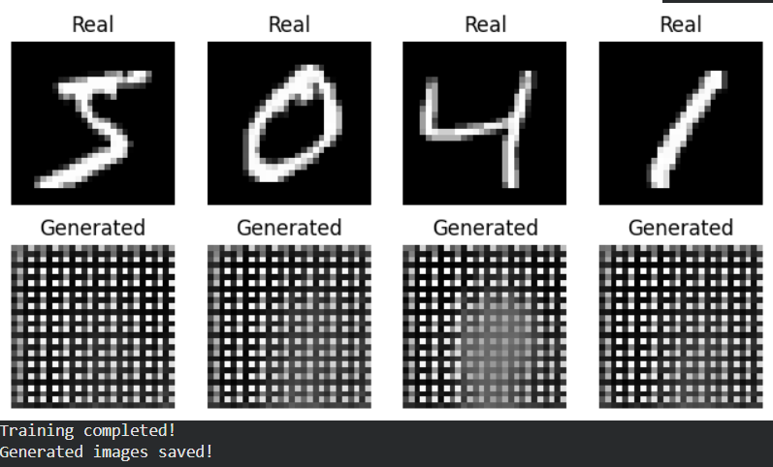

EXPECTED OUTCOME
Students will understand the architecture and working of Generative Adversarial Networks (GANs) and the interaction between the Generator and Discriminator during adversarial training. Students will learn to preprocess image data, build and train GAN models, and generate synthetic images. They will evaluate the generated images by visually comparing them with real images and analyzing the improvement in image quality during training.

POST-LAB QUESTIONS (PROVIDE BRIEF ANSWERS TO THE FOLLOWING QUESTIONS)

- What is the role of the Generator in a GAN?
The Generator creates fake/synthetic data, such as images, that look similar to real data.

- What is the role of the Discriminator in a GAN?
The Discriminator identifies whether an input image is real or fake.

- Why is random noise used as input to the Generator?
Random noise provides different starting points, allowing the Generator to create a variety of different images.

- What happens when the Discriminator becomes too strong during GAN training?
The Discriminator easily identifies fake images, making it difficult for the Generator to learn and improve.

- What is meant by mode collapse in GANs?
Mode collapse occurs when the Generator produces very similar or identical images instead of generating diverse images.

- How does the Generator improve the quality of generated images during training?
The Generator learns from the Discriminator's feedback and updates its weights to create images that are more realistic and harder to distinguish from real images.

- Mention one real-world application of GANs.
GANs can be used for image generation and image enhancement, such as creating realistic faces or improving low-resolution images.

- What is the difference between GAN training and conventional neural network training?

GAN Training | Conventional Neural Network Training
Uses two networks: Generator and Discriminator. | Usually uses a single network.
Generator creates fake data and Discriminator checks it. | Model learns directly from input and target data.
Networks compete with each other. | No competition between networks.
Learns through adversarial training. | Learns by minimizing a loss function.

SUGGESTIONS FOR DATASETS
- MNIST Handwritten Digits – https://www.tensorflow.org/datasets/catalog/mnist
- Fashion-MNIST – https://www.tensorflow.org/datasets/catalog/fashion_mnist
- CIFAR-10 – https://www.tensorflow.org/datasets/catalog/cifar10
- CelebA – https://www.tensorflow.org/datasets/catalog/celeb_a
- Oxford-IIIT Pet Dataset – https://www.tensorflow.org/datasets/catalog/oxford_iiit_pet

ASSESSMENT
Description | Max Marks | Marks Awarded
Pre Lab Exercise | 5
In Lab Exercise | 10
Post Lab Exercise | 5
Viva | 10
Total | 30
Faculty Signature

